*Special Presentation by Paul Zizka*

**IACC** and **Paul Zizka** have worked together to provide a unique opportunity to attend this amazing workshop in ***Edmonton***. Take advantage of the special price and exclusive booking opportunity for our club while you can…...

“The Art of Editing” Workshop



Paul Zizka is an award-winning mountain landscape and adventure photographer based in Banff. A prolific adventurer, Paul’s journey to capture the “under-documented” has taken him to all seven continents, as well as to each of Canada’s provinces and territories. He is frequently published in some of North America’s top magazines and has two coffee-table photography books: *Summits & Starlights: The Canadian Rockies* and *The Canadian Rockies: Rediscovered*. A passionate teacher, he hosts workshops all over the world, as well as an online community for photographers, through his company, OFFBEAT. Paul enjoys life in the mountains with his wife Meghan and their two daughters

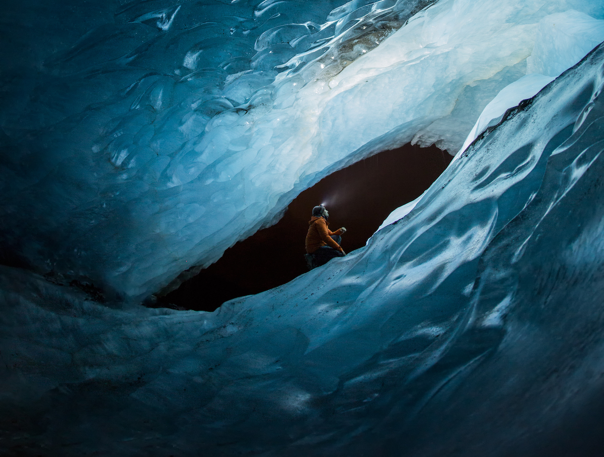

Editing images is an underrated part of the creative process in photography. For many photographers, it can be the limiting factor to stronger images (whether they are aware of it or not). Good processing skills can often make the difference between a great image and an exceptional one.

In this introduction to post-processing, Paul will discuss the importance of editing, and the tools and procedures he feels are most useful to photographers (pulling primarily from his personal toolkit). Topics include:

· the editing

· workflow, step-by-step – from the download to organizing the images and basic global adjustments in Camera Raw and Lightroom

· local adjustments and advanced tools within those applications.

· preparing your images for web and print use, sharpening, watermarking

· what Photoshop can do for you

All in all, Paul's goal is to demonstrate the value of a good post-processing workflow and how it can really take an image to the next level and the result you envisioned.

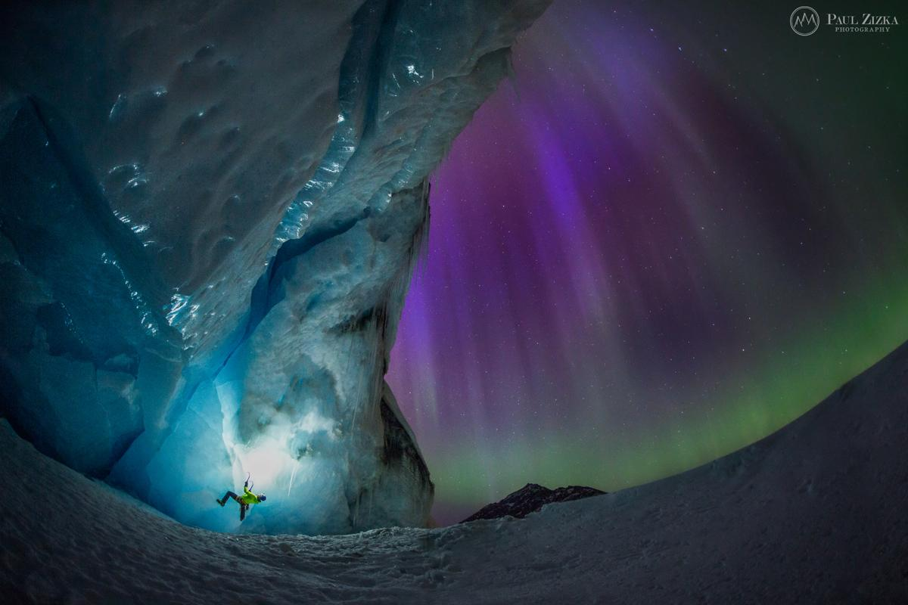

**When**: Saturday January 11, 2020. 8:00 am to 5:00 pm

**Where**: Woodvale Community Facility (Clubhouse for Millwoods Golf Club)

4540 - 50 Street, Edmonton.  
**Cost:**  $295 (plus GST)   
**Images Alberta Camera Club (IACC) and St. Albert Photography Club (SAPC) members can use special PROMO code to get $25.00 off the already discounted price.**

**SPECIAL REGISTRATION DEAL:** this workshop will be available exclusively to IACC and SAPC members until September 30, 2019. After that time the registration will be open to the public.

**Price includes:** program, coffee/tea, and lunch

**Space**: limited to 30 attendees. It is first come, first serve (including payment) Registration will close automatically when this number is reached. Please note: there is a minimum of 12 registrations required for Paul to come to Edmonton for this workshop. If this number is not reached the event will be cancelled and all funds refunded.

**Who’s it aimed at:** This workshop is for Photographers of all Levels. This event is open to both amateur and professional photographers.

**Prerequisite**: none.

**What to Bring**: Nothing required. Can bring your own note taking devices, but not required.

**Register here**: <https://www.eventbrite.ca/e/the-art-of-editing-edmonton-tickets-70025268463>

Don’t forget to enter the PROMO code on the top left of the registration page on Eventbrite to get the club discount. Also, early registration is available exclusively to IACC and SAPC members until September 30th.

**Password to get in to Eventbrite site**: Edmonton

**Password to get discount code for Eventbrite registration form**:

<https://www.imagesalberta.ca/401/login.php?redirect=/member-provided-services-members-only.html>

